Patient Safety Incident Response Plan

Effective date: 26th November 2024

Estimated refresh date: 26th November 2025

|  |  |  |  |  |
| --- | --- | --- | --- | --- |
|  | **NAME** | **TITLE** | **SIGNATURE** | **DATE** |
| **Author** | **Heather Watterson** | **Head of Clinical Governance** | **H Watterson** | **28Jan2025** |
| **Reviewer** | **Kelly Phillips** | **Director of Calea Homecare & Clinical Governance** | **K Phillips** | **28Jan2025** |
| **Authoriser** |  |  |  |  |

Table of Contents

1. Introduction 3

Scope 3

2. Our services 4

Internal Stakeholders 4

External Stakeholders 4

3. Defining our patient safety incident profile 5

Aim of a Patient Safety Incident Investigation (PSII) 5

Selection of Patient Safety Incidents for PSII 5

Timescales for Patient Safety PSII 5

Nationally-Defined Priorities to be Referred for PSII or Review by Another Team 6

Nationally-Defined Incidents Requiring Local PSII 6

Locally-Defined Incidents Requiring Local PSII 6

Criteria for Selection of Incidents for PSII: 6

Data Source 7

4. Defining our patient safety improvement profile 9

5. Our patient safety incident response plan: national requirements 9

6. Our patient safety incident response plan: local focus 11

Investigation Stages 12

7. Glossary of terms 13

# 1. Introduction

This patient safety incident response plan (PSIRP), sets out how Fresenius Kabi/Calea UK intends to respond to patient safety incidents over a period of 12 to 18 months. The plan is not a permanent rule that cannot be changed. We will remain flexible and consider the specific circumstances in which patient safety issues and incidents occurred and the needs of those affected. Fresenius Kabi/Calea UK will seek to learn from patient safety incidents reported by staff, patients and their families as part of our work to continually improve the quality and safety of the care we provide.

This plan will help us measurably improve the efficiency of our local patient safety incident investigations (PSIIs) by:

* Refocusing PSII towards a systems approach in line with PSIRF and the identification of connected causatory factors and systems issues
* Focusing on addressing these factors to prevent or continuously and measurably reduce repeat patient safety risks and incidents
* Transferring the emphasis from the quantity to the quality of PSIIs such that it increases our stakeholders’ (patients, families and staff) confidence in the improvement of patient safety through learning from incidents
* Demonstrating the added value from the above approach
* Ensuring our policy reflects the needs and actions required.

### Scope

A PSIRP is a requirement of each provider or group/network of providers delivering NHS-funded care.

This document should be read alongside the introductory Patient Safety Incident Response Framework (PSIRF) 2020, which sets out the requirement for this plan to be developed.

Fresenius Kabi/Calea UK will continue to develop the planning aspects of this PSIRP with the assistance and approval of our identified lead commissioner.

The aim of this approach is to continually improve. As such, this document will be reviewed annually and approved by the Executive Leadership Team at Fresenius Kabi/Calea UK in conjunction with the PSIRF Policy.

# 2. Our services

Fresenius Kabi UK are a healthcare company who specialise in lifesaving medicines and technologies for infusion, transfusion, clinical nutrition and biosimilars. Our products and services are used to help care for critically and chronically ill patients. Calea UK Ltd is part of Fresenius Kabi UK and includes the provision of a specialist community nursing service which provides a service to patients in their own homes or other care settings such as care homes. The nurses train patients and carers and offer clinical support with parenteral and intravenous treatments and nutritional therapies. In partnership with clinical specialists and commissioning teams, we aim to provide a seamless transfer of care for patients when they are being discharged from hospital to home.

### Internal Stakeholders

The list of internal stakeholders for the complex elements of the patients’ care would include representatives from different clinical and non-clinical teams (e.g. Management, Governance, Safeguarding, Pharmacy, Quality Control, Quality Assurance, Distribution).

### External Stakeholders

Depending on the incident to be investigated, the external stakeholders may vary depending on their subject matter expertise. This may include patient groups and patient and public representative organisations (e.g. Local Authority safeguarding, ICB leads, NHS Hospital Trusts, the Police, professional body representatives and the CQC).

To ensure that GDPR regulations are adhered to, any information shared with external parties would need to be either with consent from the individual or in their best interests.

Through the process of any patient safety incident investigation, all internal and external stakeholders will need to be kept updated of any outcomes and findings.

At the start of each PSII, a Terms of Reference will need to be agreed. This will identify who is required to be involved in the process, what their role is, who has the oversight of the workflow and process and how the information is to be communicated.

# 3. Defining our patient safety incident profile

### Aim of a Patient Safety Incident Investigation (PSII)

PSIIs are conducted for systems learning and safety improvement. This is achieved by identifying the circumstances surrounding incidents and the systems-focused, interconnected causatory factors that may appear to contribute towards patient safety incidents. These factors must then be targeted with effective system improvements to either prevent or continuously and measurably reduce repeated incidents.

There is no remit in PSII to apportion blame or determine liability, preventability or cause of death.

There are several other types of investigation which, unlike PSIIs, may be undertaken. Examples include complaints, human resource, professional regulation, regulatory bars or criminal investigations. As the aims of each of these investigations differ, they need to continue to be conducted by the subject matter experts as separate entities to be effective in meeting their specific intended purposes.

### Selection of Patient Safety Incidents for PSII

In view of the above, the selection of incidents for PSII is based on the:

* Actual and potential impact of the incident’s outcome (harm to people, service quality, public confidence, products, funds, etc.)
* Likelihood of recurrence (including scale, scope and spread)
* Potential for new learning in terms of:
  + Enhanced knowledge and understanding of the underlying factors
  + Improved efficiency and effectiveness
  + Opportunity to influence wider system improvement

### Timescales for Patient Safety PSII

Where a PSII for learning is indicated, the investigation must be started as soon as possible after the patient safety incident is identified.

PSIIs should ordinarily be completed within one to three months of their start date.

In exceptional circumstances, a longer timeframe may be required for completion of the PSII. In this case, any extended timeframe should be agreed between Fresenius Kabi/Calea and the patient/family/carer.

No local PSII should take longer than six months. A balance must be drawn between conducting a thorough PSII, the impact that extended timescales can have on those involved in the incident, and the risk that delayed findings may adversely affect safety or require further checks to ensure they remain relevant. (Where the processes of external bodies delay access to some information for longer than six months, a completed PSII can be reviewed to determine whether new information indicates the need for further investigative activity.)

### Nationally-Defined Priorities to be Referred for PSII or Review by Another Team

The National priorities for referral to other bodies or teams for review or PSII (described in the PSIRF) for the period 2020 to 2021 are:

* Child deaths (Child death review statutory and operational guidance):
  + Incidents must be referred to child death panels for investigation
* Deaths of persons with learning disabilities:
  + Incidents must be reported and reviewed in line with the Learning Disabilities Mortality Review (LeDeR) programme
* Safeguarding incidents:
  + Incidents must be reported to our local safeguarding lead for review/multi-professional investigation.

### Nationally-Defined Incidents Requiring Local PSII

Nationally-defined incidents for local PSII are set by the PSIRF and other national initiatives for the period 2020 to 2021. These are:

* Incidents that meet the criteria set in the Never Events list 2018
* Incidents that meet the ‘Learning from Deaths’ criteria; that is, deaths clinically assessed as more likely than not due to problems in care.

### Locally-Defined Incidents Requiring Local PSII

Based on a local analysis and review of the local incident reporting profile, local priorities for PSII have been set by Fresenius Kabi/Calea UK, for the period of 18 months.

* Locally-defined patient safety incidents requiring PSII.
* An unexpected patient safety incident which signifies an extreme level of risk for patients, families and carers, staff or organisations, and where the potential for new learning and improvement is so great (within or across a healthcare service/pathway) that it warrants the use of extra resources to mount a comprehensive PSII response.
* Locally-predefined patient safety incidents requiring investigation. Key patient safety incidents for PSII have been identified through analysis of local data and intelligence from the past four years of available data.

### Criteria for Selection of Incidents for PSII:

* Actual and potential impact of outcome of the incident (harm to people, service quality, public confidence, products, funds, etc.)
* Likelihood of recurrence (including scale, scope and spread)
* Potential for learning in terms of: – enhanced knowledge and understanding – improved efficiency and effectiveness (control potential) – opportunity for influence on wider systems improvement.

### Data Source

The patient safety incident risks have been profiled using the organisations incident reporting platform, Ulysses.

|  |  |  |  |
| --- | --- | --- | --- |
|  | 2020/2021 | 2021/2022 | 2022/2023 |
| Never Events | 0 | 0 | 0 |
| Serious Incident Investigations | 0 | 1 | 0 |
| Critical incidents Root Cause Analysis Investigations (internal/departmental only) | 5 | 15 | 10 |

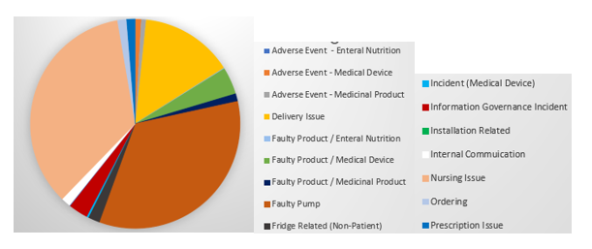**Fig 3.1 Incident cause group for 2020**

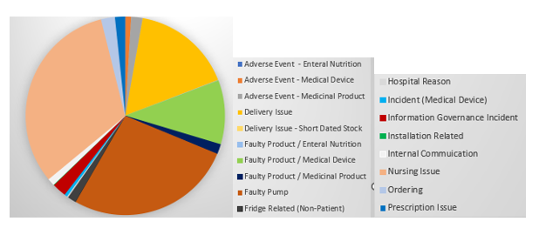**Fig 3.2 Incident cause group for 2021**

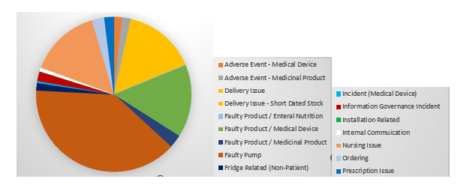**Fig 3.3 Incident cause group for 2022**



**Fig 3.4 Incident cause group for 2023**

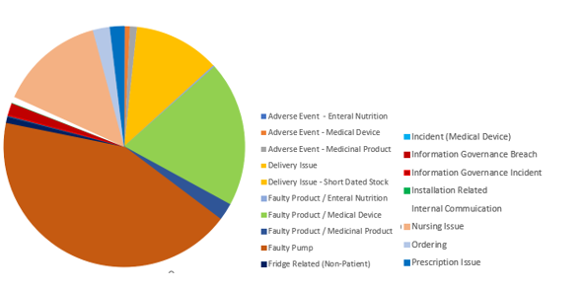

# 4. Defining our patient safety improvement profile

PSIRF sets the national requirements listed within the plan. The remainder of the plan is data driven, covering the last 4 years which has provided an insight into the key patient safety incident themes, patterns and trends, repeat causality and the greatest opportunities for learning to improve patient safety outcomes.

The Governance Team has engaged with internal and external key stakeholders, having reviewed business wide data from various sources to determine our safety profile and identify the optimum methods of review to ensure maximum learning and effective plans to improve the quality and safety of services. The team commenced planning for PSIRF early 2023 and have had a number of regular engagement meetings with the Integrated Care Board (ICB) as part of a collaborative with other independent providers and Hospital Trusts.

# 5. Our patient safety incident response plan: national requirements

|  |  |  |
| --- | --- | --- |
| **Patient safety incident type** | **Required response** | **Anticipated improvement route** |
| Incidents meeting the Never Events criteria | PSII | Create departmental actions and monitor through the clinical governance reporting framework |
| Death thought more likely than not due to problems in care (incident meeting the learning from deaths criteria for patient safety incident investigations (PSIIs)) | PSII | Create departmental actions and monitor through the clinical governance reporting framework |
| Accidents and Incidents that are of a reportable nature | CQC, LeDeR, RIDOR, MHRA | Respond to recommendations as required and feed actions into the Quality Framework |
| Death of a person with learning disabilities | Refer for Learning Disability Mortality Review (LeDeR) Locally-led PSII (or other response) may be required alongside the LeDeR – organisations should liaise with this | Create local organisational actions and feed these into the Quality Framework |
| Safeguarding incidents in which:   * babies, children, or young people are on a child protection plan; looked after plan or a victim of wilful neglect or domestic abuse/violence * adults (over 18 years old) are in receipt of care and support needs from their local authority * the incident relates to FGM, Prevent (radicalisation to terrorism), modern slavery and human trafficking or domestic abuse/violence | Refer to local authority safeguarding lead Healthcare organisations must contribute towards domestic independent inquiries, joint targeted area inspections, child safeguarding practice reviews, domestic homicide reviews and any other safeguarding reviews (and inquiries) as required to do so by the local safeguarding partnership (for children) and local safeguarding adults boards | Create local organisational actions and feed these into the Quality Framework  To ensure that staff, families and service users are supported at all stages of any investigation |
| **Patient safety incident type** | **Required response** | **Anticipated improvement route** |
| Domestic homicide | A domestic homicide is identified by the police usually in partnership with the community safety partnership (CSP) with whom the overall responsibility lies for establishing a review of the case.  Where the CSP considers that the criteria for a domestic homicide review (DHR) are met, it uses local contacts and requests the establishment of a DHR panel The Domestic Violence, Crime and Victims Act 2004 sets out the statutory obligations and requirements of organisations and commissioners of health services in relation to DHRs | Respond to recommendations as required and feed actions into the Quality Framework |

# 6. Our patient safety incident response plan: local focus

|  |  |  |
| --- | --- | --- |
| **Patient safety incident type or issue** | **Planned response** | **Anticipated improvement route** |
| Critical Alert | ICA/Swarm huddle | Multi-disciplinary team review to agree criticality of event and determine level of investigation required |
| Medication Dispensing | ICA/Swarm huddle | improvement plan focussing on Quality and Safety |
| Nursing Procedure Error | Simple investigation or Swarm huddle if deemed appropriate | improvement plan focussing on Quality and Safety |
| Incorrect quantity sent | Simple investigation | improvement plan focussing on Quality and Safety |
| Reported pump under/over delivery | Simple investigation | Thematic review where required (data driven) |
| Defective product/component | External investigation (3rd party/Production unit). Simple local investigation where relevant | Thematic review where required (data driven) |
| Regulatory Requirements   * Handling of Adverse Drug reactions * Medical Devices * Food Safety | Please refer to Global-SOP-VI-000002490 Handling of adverse Drug Reactions and other ICSRs  Please refer to the Regulatory Affairs and/or National Safety Officer |  |
| Incidents resulting in moderate or severe harm to patient | Statutory Duty of Candour and:  Patient Safety Incident Investigation where agreed or appropriate learning response tool kit, i.e. After Action Review, MDT or Swarm Huddle | Improvement plan focussing on Quality and Safety |
| No/low harm incidents | Simple investigation | Improvement plan focussing on Quality and Safety |
| Near miss incidents | Local and thematic review | Thematic review where required (data driven) |
| Home Parenteral Support Framework Requirements   * Catheter related blood stream infections * PICC migrations * Catheter occlusions * Rapid over infusion | Root cause analysis | Improvement plan focussing on Quality and Safety  Thematic review where required (data driven) |
| After Action reviews can be initiated following any incident investigation if the investigator deems it appropriate | | |

### Investigation Stages

The table below outlines the different stages of the investigation process and the resource required for each patient safety incident investigation. The exact resources required will depend on the specific incident, and therefore the resources stated are estimations. It also provides an indication on the differing resource requirements for the relevant staff groups. This should be reviewed in conjunction with the PSIRF policy.

|  |  |
| --- | --- |
| **Investigation Stage** | **Responsibility** |
| 1. Plan the Investigation | |
| * Appoint investigators who are trained, competent, have secure protected time and sufficient support. * Inform and engage with the patient/family and staff involved in agreeing scope. | * Clinical Governance, relevant internal team * Quality Assurance Team |
| 2. Gather and map the information (WHAT Happened) | |
| * Identify the WHO, WHERE and WHEN of the incident. * Identify WHAT happened * Map the incident timeline from the healthcare record, incident report and/or complaint letter. * Add further detail and achieve mutual understanding via meetings/interviews with the patient/family and staff involved | * Investigation Lead |
| 3. Identify Problems (HOW it happened and variations from what was expected to happen) | |
| * Identify and reference good practice requirements (work as imagined) * Identify the key problems arising | * Investigation Lead /Subject Matter Expert |
| 4. Analyse contributory and causal factors (WHY these key problems arose) | |
| * Observe and discuss how work is routinely done (work as done) * Search for contributory and causal factors for each key problem (deep-seated reasons WHY) | * Investigation Lead |
| 5. Write Investigation Report- with clarity, openness and in full consultation with patient/family and staff | |
| * Write investigation report | * Investigation Lead |
| 6. Develop Recommendations and Action Plan | |
| * Identify and develop strong systemic improvements (using Human Factor principles) * Develop an action plan. * Review effectiveness of actions/improvements in reducing or preventing repeat incidents | * Investigation lead/subject matter expert/Clinical Governance Committee |

# 7. Glossary of terms

PSIRF - Patient Safety Incident Response Framework

This is a national framework applicable to all NHS commissioned outside of primary care. Building on evidence gathered and wider industry best-practice, the PSIRF is designed to enable a risk-based approach to responding to patient safety incidents, prioritising support for those affected, effectively analysing incidents, and sustainably reducing future risk.

PSIRP - Patient Safety Incident Response Plan

The local plan sets out how we will carry out the PSIRF locally, including our list of local priorities. These have been developed through a coproduction approach with the quality and governance team leads supported by analysis of local data.

PSII - Patient Safety Incident Investigation

PSIIs are conducted to identify underlying system factors that contributed to an incident. These findings are then used to identify effective, sustainable improvements by combining learning across multiple patient safety incident investigations and other responses into a similar incident type. Recommendations and improvement plans are then designed to effectively and sustainably address those system factors and help deliver safer care for our patients.

AAR – After Action Review

A method of evaluation that is used when outcomes of an activity or event have been particularly successful or unsuccessful. It aims to capture learning from these to identify the opportunities to improve and increase to occasions where success occurs.

Initial Criticality Assessment/SWARM

This approach allows for the rapid review of an incident – staff swarm to a discussion to allow for it to be explored on a systematic basis and to support those immediately involved.

Simple Investigation

Mangers form in Ulysses system updated with review findings and closed.

Never Event

Patient safety incidents that are considered to be wholly preventable where guidance or safety recommendations that provide strong systemic protective barriers are available at a national level and have been implemented by healthcare provider.